

Claims Online  
Training Manual

Revision No. 2.0

Date Last Updated: March 12, 2010

Technology Services Training

FedEx Corporate Services

90 FedEx Pkwy

Collierville, TN 38017

© Copyright 2009, FedEx Services. All rights reserved.  
No portion of this document may be copied, displayed, reproduced, or used   
without the express written consent of FedEx Services.

REVISION HISTORY

Revisions to this document are listed by date in the table below.

|  |  |  |  |
| --- | --- | --- | --- |
| Date | Revision # | Revised by | Description |
| 02/23/2009 | 0.0 | Karen Kearbey | Initial Draft. Based on the following source documents:  SalesPoint  KnowledgeBase  Existing Claims Online Student Manual  Claims Online application |
| 02/24/2009 | 0.1 | Karen Kearbey | Moved the “Attach Supporting Documentation” section to the correct place.  Made minor cosmetic changes. |
| 10/14/09 | 0.2 | Karen Kearbey | Verified content and updated to match new MS Word template. |
| 10/20/09 | 0.3 | Karen Kearbey | Made changes to each claim process for Express, International, and Ground to streamline the process and make the document easier to follow. |
| 11/13/09 | 0.4 | Janice Richie | Changed the title page, the revision date, and the version number. |
| 02/18/10 | 1.0 | Janice Richie | Added Freight as an option for Claims, and included updates on FCL Account type selection, i.e. Express/Ground and Multiple Accounts. |
| 03/12/10 | 2.0 | Teresa Brown | Added comments indicating FedEx Ground Call Tags and FedEx Express Tags are included. |

Contents

Overview 5

Rules When Filing a Claim 5

Government Regulations Impact 5

Claims Restrictions 5

Common Reasons for Having to File a Claim 5

Requirements to File a Claim 6

Delivery Signature Options Impact to Claims 6

Express Domestic Claims 7

Types of Express Domestic Claims 7

How to Avoid Having to File a Claim 7

Rule 1 – Declare a Value for the Shipment 7

Rule 2 – Correctly Identify the Product / Commodity 8

Required Steps Customers Must Take to File a Claim 9

Step 1 – File Claim Immediately 9

Step 2 – Retain all Packaging; Inner, Outer, Contents 10

Step 3 – Include Supporting Documentation (as Needed) 10

Step 4 – Allow for an Inspection (if Needed) 11

Additional Contact Resources 11

Settlement Guidelines 12

Express Domestic 12

Domestic Freight 12

Express International Claims 13

Types of Express International Claims 13

How to Avoid Having to File a Claim 13

Rule 1 – Declare a Carriage Value for the Shipment 13

Rule 2 – Declare a Customs Value for the Shipment 14

Rule 3 – Accurately Denote the Product / Commodity 14

Required Steps Customers Must Take to File a Claim 15

Step 1 – File Claim Immediately 15

Step 2 – Retain all Packaging; Inner, Outer, Contents 15

Step 3 – Include Supporting Documentation (as Needed) 16

Step 4 – Allow for an Inspection (if Needed) 16

Additional Contact Resources 17

Settlement Guidelines 17

Express International – Not Freight 17

Express International – Freight Services 17

Ground Claims 18

Types of Ground Claims 18

How to Avoid Having to File a Claim 18

Rule 1 – Declare a Value for the Shipment 18

Rule 2 – Correctly Identify the Product / Commodity 19

Required Steps Customers Must Take to File a Claim 19

Step 1 – File Claim Immediately 19

Step 2 – Retain all Packaging; Inner, Outer, Contents 19

Step 3 – Include Supporting Documentation (as Needed) 19

Step 4 – Allow for an Inspection (if Needed) 20

Additional Contact Resources 21

Customer Contact Resource 21

Settlement for Ground Claims 21

Ordering Ground Claims Reports 21

Available Customer Claim Reports 22

Express Domestic and International Claims Customer Report 22

Summary Report 22

Detail Report 22

Ratio Report 22

Express and Ground Claims Customer Report 22

How to File a Claim Using Claims Online 23

Filing a Claim Online – Claims Online 23

Filing a Claim by Phone 24

Navigational Links - Submit a Claim Home Page 24

Submit a Claim Link 24

Claim Status Summary link 24

Claim Reports link 24

Additional Supporting Documents Link 24

Account Preferences link 24

Information Resources link 25

My Profile link 25

Logout link 25

Submitting a Claim 26

Step 1 – Submit a claim 26

Possible Claims Alert Messages 27

Step 2 – Complete claim form 29

Step 3 – Verify & submit 32

Step 4 – Claim confirmation 33

Attach Additional Supporting Documents 34

Account Preferences 35

Email Preferences screen 36

Claim Payment Preferences link 36

Manage Additional Users link 37

Invite New Users button 37

Change Administrator link 37

Claim Status Summary 38

Claim Reports 39

# Overview

FedEx Claims Online is an online filing option to file claims for FedEx Express, Ground, or Freight claims on the following:

* U.S. Domestic shipments (including FedEx Ground Call Tag and FedEx Express Tag shipments)
* U.S. shipments outbound to other countries
* Canada shipments inbound to the U.S.

The Claims Online application on fedex.com offers customers the ability to file a claim for package damage, complete loss or partial loss of shipments, view claim summary status, view, and download claim reports, choose the claim payment type, invite others, and set preferences.

All customers must log in to the application using their fedex.com Customer Login (FCL) ID and password. At the time of the FCL login process, based on the account number entered or selected, the system will validate whether the customer is a:

* FedEx Express/Ground Account Only
* FedEx Freight Account Only
* FedEx Freight/Express/Ground Account

**NOTE:** The first person that registers for access automatically becomes the account administrator.

## Rules When Filing a Claim

Express and Ground rules and Domestic and International rules for filing claims are different, so be aware of each FedEx OpCo’s rules and the different business rules.

Some of those rules that differ are the:

* Timeframes allowed
* Surcharges assessed
* Acceptable documentation allowed

## Government Regulations Impact

FedEx Ground is governed by the Surface Transportation Board (formerly known as the Interstate Commerce Commission or ICC).

FedEx Express Domestic is governed by the Federal Aviation Agency (FAA).

FedEx Express International is governed by the Warsaw Convention. The Warsaw Convention allows each country to pass amendments that can potentially override the FedEx Service Guide; meaning there are country-specific limitations, which could affect the payment of a claim.

## Claims Restrictions

Claims cannot be filed on International inbound shipments, except inbound shipments from Canada to the U.S.

FedEx Ground claims done on-line are limited to six tracking numbers if filed for the same shipper, recipient, and ship date.

## Common Reasons for Having to File a Claim

Three common reasons for filing a claim to FedEx are:

* Failure to declare a value
* Non-compliance with set time limits
* Non-compliance with claim-supporting documentation requirements

## Requirements to File a Claim

The customer must know the account number, tracking number, ship date, whether the claim is for loss or damage, the shipment contents, the replacement value, and/or the repair cost

A Letter of Authorization is also required if the claim settlement is to be paid to an **entity** other than the shipper An **entity** refers to businesses owned by a company with a minimum of 51 percent ownership.

## Delivery Signature Options Impact to Claims

Claims with FedEx Delivery Signature Options are evaluated on a case-by-case basis:

* The Claims Department first looks at the overall movement of the shipment to ensure that no service failure occurred. Then, they determine whether the recipient address is a residence or business.
* Shipments with a declared value equal to or greater than $500 U.S. dollars must have a signature, regardless if a signature option was chosen.
  + If the declared value is less than $500, the shipper did not choose a signature option, and no other exceptions apply, the courier may leave the shipment at a residence. If the package is lost or stolen, FedEx will not honor the claim.
  + If the declared value is less than $500, and the shipper did choose a signature option, the Claims Department evaluates if the delivery process was followed in accordance with the signature option chosen. If procedures were followed, then FedEx will honor a claim for loss.

# Express Domestic Claims

This section covers the following for Express Domestic Claims:

* Types of Claims
* How to Avoid Having to File a Claim
* Required Steps Your Customer Must Take in Order to File a Claim

## Types of Express Domestic Claims

There are two types of claims for Express Domestic shipments:

1. Loss or mis-delivery
   1. Loss means a lost package for which there is no record of delivery
   2. Mis-delivery means delivery to the wrong address as indicated on FedEx delivery records
2. Delay, damage, shortage, or failure to properly collect or deliver a Collect on Delivery (C.O.D.) payment
   1. Delay includes deliveries that do not meet commitment times and the consequences the delay caused the customer (within declared value limits). These are called consequential damages. Examples are restocking fees and fees for tradeshow expenses. FedEx Express does not consider potential loss of sales
   2. Damage includes damage of any type, visible or concealed
   3. Shortage means missing contents
   4. Failure to properly collect or deliver a C.O.D. payment

**NOTE:** Money-Back Guarantee (MBG) requests, which are usually handled by Customer Service.

## How to Avoid Having to File a Claim

The best way to avoid claims issues is to follow the rules listed below before shipping the package:

### Rule 1 – Declare a Value for the Shipment

Declare a value on the contents of the package. The declared value sets the maximum amount FedEx might pay for a claim. Declared value represents FedEx's maximum liability in connection with the shipping of a package, including, but not limited to, any loss, damage, delay, mis-delivery, non-delivery, misinformation, failure to provide information, or mis-delivery of information relating to the shipment.  
**Reminder:** Declared value is not considered 'insurance'; FedEx does not provide insurance of any kind.

For domestic Express package services, unless a higher value is declared and paid for, FedEx' liability for each package is limited to $100. For each package that exceeds $100 in declared value, a surcharge is assessed for each $100 (or fraction thereof) of additional declared value.

#### Maximum Declared Value Restriction – Package Types

The maximum declared value contents of any FedEx Envelope or FedEx Pak is $500.

Unless the customer is shipping an item of extraordinary value or otherwise specified in the Service Guide, the maximum declared value per package for any FedEx First Overnight, FedEx Priority Overnight, FedEx Standard Overnight, FedEx 2Day, FedEx Express Saver, FedEx 1Day Freight, FedEx 2Day Freight, FedEx 3Day Freight, FedEx Ground Service, and FedEx Home Delivery Service shipment is $50K.

#### Declared Value Rules for Express Domestic Freight Services

FedEx' liability for each piece (single handling unit) is limited to $100 or $1 per pound; whichever amount is greater, unless a higher value is declared and paid by the customer. When the declared value exceeds the greater of the two: $100 or $1 per pound per shipment, an additional amount will be charged for each $100 (or fraction thereof) of additional declared value.

|  |  |
| --- | --- |
|  |  |
| **🏳** **HEADS UP NOTE** | Declared value for carriage raises the claim from FedEx’ limit of liability up to the amount the customer declared for carriage (transportation).  Declared customs value is strictly for customs purposes to clear the shipment and is the fair market value of the product / commodity  Declared value for carriage is optional, and an additional charge can be assessed.  **NOTE:** Refer to the FedEx Service Guide for more details. |
|  |  |

### Rule 2 – Correctly Identify the Product / Commodity

Pay attention to the Product / Commodity for Express Domestic shipment, depending upon the commodity the customer is shipping. FedEx may not pay the claim, or will severely restrict the amount paid.

#### Product / Commodities for Express Domestic Claims

The five types of product / commodities for which FedEx will either pay no claim or severely restrict the amount include:

1. Commodities limited to $1K maximum declared value. These include, but are not limited to, customized, or personalized musical instruments, artwork and film, jewelry, and plasma screen televisions.
2. Prohibited items: If a package contains a prohibited commodity, FedEx will not pay any claims, even if a value is declared on shipping documents. Check the Service Guide for a list of prohibited items.
3. Liabilities not assumed. The Service Guide has an exhaustive list of “Liabilities Not Assumed.” Specific examples include, but are not limited to, fluorescent tubes, scale models, and prototypes.  
   **NOTE:** Shipments of electronic data storage and computers have specific requirements; check the Service Guide.
4. Perishables: Choose an expedited service for transportation of perishable items; calculate weekends and holidays into the transit time and have FedEx Packaging Design and Development approve all packaging. Check the Service Guide for complete details.

The FedEx Packaging Design and Development (PDD) Department offers free package testing and design. Additionally, field-packaging engineers may be available to work one-on-one with customer's specialized packaging needs, such as:

* FedEx Temperature-Controlled Packaging Consultation and Referral Program
* Live fish and live harmless reptiles

Participating Operating Companies

FedEx Express and FedEx Ground (excluding Home Delivery)

Contact Email Address

PDD: packagingservices@fedex.com

Additional Resources

PDD home page: http://pkg.rmtc.fedex.com/

**Application for Packaging Services** http://images.fedex.com/us/services/pdf/PKG_Services_Application.pdf

Packaging Design and Development Features

PDD provides free package testing and/or design services

* Online brochures and the application can be accessed by you or customers
* Local field packaging engineers who can assist you; see <http://pkg.rmtc.fedex.com/>

**NOTE:** Packaging is important in determining whether FedEx will pay a claim. It is the shipper's responsibility to mark and package the commodity in compliance with the specifications of FedEx Packaging Design and Development. If this is not done, then FedEx will not pay a claim.

1. Other considerations: If your customer uses a package consolidator, or their shipments fall into one of the categories below, check the FedEx Service Guide for more details:

* Alcohol (see alcohol shipping for Express and Ground)
* Firearms (Express Only)
* Live animals, live harmless reptiles, live fish, and ornamental marine life (Express Only)
* Firearms (firearms and ammunition must be shipped separately) (Ground Only)
* Shipments for which a package consolidator is used (Ground Only)

## Required Steps Customers Must Take to File a Claim

Customers must follow the four steps listed below to file an Express Domestic claim.

### Step 1 – File Claim Immediately

The shipper, recipient, or third party can file a FedEx Express claim and should do so immediately, if needed by using the FedEx Claims Online application, or by calling Customer Service at 1.800.463.3339. If calling, the customer will need to provide the following details.

* Completed claim form
* FedEx air waybill or tracking number
* Date of shipment
* Complete shipper and recipient information
* Number of pieces
* Shipment weight
* Contact name and phone number with extension

If the customer files the claim through Customer Service, a Customer Service Representative will fax a claim form and Frequently Asked Questions (FAQs) to them. If using FedEx Claims Online, the customer can access related links, including FAQs.  
**Reminder:** It is critical for customers to file immediately because of set time limits for FedEx Express Domestic claims.

#### Time Limits for Express Domestic Claims

The customer must notify FedEx Express within 21 calendar days from the delivery date for damage, delay, shortage, or failure to properly collect or deliver a Collect on Delivery (C.O.D.) payment:

The customer must notify FedEx Express within nine months from the ship date for loss or mis-delivery.

If supporting documentation for Express Domestic claims is necessary, customers have nine months after the shipment is tendered to submit all necessary documents.

### Step 2 – Retain all Packaging; Inner, Outer, Contents

Keep all outer and inner packaging, materials, and contents.

### Step 3 – Include Supporting Documentation (as Needed)

Provide all supporting documentation for the Express Domestic claim, as necessary.

#### Supporting Documentation for Express Domestic Claims

The need depends on the condition of the shipment, value, and other factors. FedEx Express requires supporting documents only for claims equal to or greater than $100 in declared value.

The following is examples of supporting documentation (copies are acceptable):

* Invoice proving the amount paid for the merchandise and the date of purchase
* FedEx shipping documents
* Serial number(s) of the merchandise, if applicable
* Itemized repair invoice or statement of non-repair, if required (depends on condition and value)
* Finalized order confirmation screen and proof of payment if ordered from the Internet
* The appraisal for antiques
* Expense statements or other proof for consequential damages

The customer should attach the documentation to the claim form.

* If the customer is using FedEx Claims Online, they can attach soft copies of documentation when filing the claim
* If the customer calls Customer Service, the Customer Service agent will provide the claim form. The claim form is also available at [www.fedex.com/us/customer/claims](http://www.fedex.com/us/customer/claims). The customer can then mail or fax the form and documentation to:

FedEx

Cargo Claims Dept.

P.O. Box 256

Pittsburgh, PA 15230

Fax: 1.877.229.4766

|  |  |
| --- | --- |
|  |  |
| **🏳** **REMINDER** | If the person filing the claim faxes the claim paperwork, they will receive the confirmation letter by return fax. |
|  |  |

### Step 4 – Allow for an Inspection (if Needed)

Allow for an inspection of the shipment, if required.

#### Inspection Process for FedEx Express Domestic Claims

The higher the value of the claim, the more likely it is that there will be an inspection and it is required if the declared value equals or exceeds $1K. There are situations when FedEx Express requires a claims inspection even when the declared value is less than $1K, but those situations are rare.

The claims agent will set up the inspection with both the customer and a FedEx or FedEx-contracted Packaging Engineer. The Packaging Engineer will go to the package's location to make the inspection.

The Packaging Engineer will submit a report to Claims within five to seven business days. After receiving this report, claims will make a decision within two business days and will call the person who filed the claim.

## Additional Contact Resources

The Claims Sales Hotline helps Account Executives with specific Express Domestic claims issues. The Sales Hotline number is 1.877.522.7076 (Option 21).  
**Reminder:** The Claims Sales Hotline line is for the following purposes only:

* Internal use only (do not give this number to customers)
* Problem resolution, not for general information

Do not conference in the customer while speaking to the Hotline Representative. If this occurs, the Hotline Representative will politely discontinue the call and remind you that the Claims Sales Hotline is for Sales only.

|  |  |
| --- | --- |
|  |  |
| **🏳** **NOTE** | The Claims Sales Hotline group will provide an answer within one business day from the date of the initial request. |
|  |  |

## Settlement Guidelines

After FedEx Express settles a Domestic claim or Domestic Freight, there are a few important guidelines to consider.

### Express Domestic

FedEx Express handles Domestic charges in this manner:

* The sender receives the claim settlement unless they make special arrangements with FedEx. Special arrangements differ according to each set of circumstances; the claims agent assigned to the claim will advise what is necessary  
  **NOTE:** if the claim is less than $1K, FedEx will settle with the party who paid the freight charges if he/she filed the claim. This is called 'Payer of Transportation.'
* After the customer has submitted all required documentation and FedEx has approved the claim, the customer can expect a claim check within five to seven business days. FedEx sends claim checks for less than $1K via the U.S. Postal Service (USPS) and checks for more than $1K via FedEx Priority Overnight.
* Paid claims may require that any salvage be turned over to FedEx.

### Domestic Freight

FedEx Express handles Domestic Freight charges in this manner:

Freight charges are included in the claim check if the customer paid cash or already paid the FedEx invoice.

* If the customer has not already paid freight charges, FedEx will issue a credit
* If the customer paid freight charges by credit card, the Claims group will request that the credit card be credited
* If damage occurred to only a portion of a multiple-piece shipment (MPS), then FedEx Express will not refund full freight charges.

# Express International Claims

This section covers the following for Express International Claims:

* Types of Claims
* How to Avoid Having to File a Claim
* Required Steps Your Customer Must Take in Order to File a Claim

## Types of Express International Claims

There are two types of claims for Express International shipments:

1. Loss or mis-delivery

* Loss means a lost package for which there is no record of delivery
* Mis-delivery means delivery to the wrong address as indicated on FedEx delivery records

2. Delay, damage, or shortage

* Delay includes deliveries that do not meet commitment times and the consequences the delay caused the customer (within declared value limits). These are called consequential damages. Examples are restocking fees and fees for tradeshow expenses. FedEx Express does not consider potential loss of sales
* Damage is damage of any type, whether visible or concealed
* Shortage means missing contents

**NOTE:** International Customer Service handles Money-Back Guarantee (MBG) requests

## How to Avoid Having to File a Claim

The best way to avoid claims issues is to follow the rules listed below before shipping the package:

### Rule 1 – Declare a Carriage Value for the Shipment

FedEx pays claims based on either the declared value for carriage (transportation) or the weight of the package, whichever is greater, unless a higher value for carriage is declared. If a higher value is declared, the customer will pay a greater carriage charge.  
The Warsaw Convention limits FedEx liability for loss, delay, or damage to a customer's shipment, unless the customer declares a higher value for carriage and pays the required fee (based on the declared value).  
**NOTE:** The interpretation of the Warsaw Convention's liability limits varies depending on the destination country. If the Warsaw Convention applies to a particular customer's shipment, FedEx’ liability is limited to 17 Special Drawing Rights (SDRs) per kilo. Otherwise, FedEx’ liability is limited to $9.07 per lb. or $20.38 per kg. The per-pound/per-kilogram amount can vary based on currency fluctuation and other factors. Go to http://www.xe.com/ucc/ for the most up-to-date information.

|  |  |
| --- | --- |
|  |  |
| **🏳** **TIP** | The Service Guide specifically states that FedEx Express does not provide insurance coverage of any kind. The customer should contact an insurance agent if insurance coverage is desired. |
|  |  |

### Rule 2 – Declare a Customs Value for the Shipment

#### Express International – Not Freight

Customs Value is the selling price or fair market value for the item(s) within the shipment.  
**Reminder:** The declared value for customs must always agree with the value shown on the Commercial Invoice.

|  |  |
| --- | --- |
|  |  |
| **☺  NOTE** | For International shipments, there is often confusion about the difference between Declared Value for Carriage and Declared Value for Customs.   * Declared Value for Carriage raises the claim from FedEx's limit of liability up to the amount the customer declared for carriage. * Declared Value for Customs is strictly for customs purposes to clear the shipment. Declared value for carriage is optional, and there is an additional charge |
|  |  |

#### Express International – Freight Services

FedEx' liability for each piece (single handling unit) is limited to $100 or $1 per pound; whichever amount is greater, unless a higher value is declared and paid by the customer. When the declared value exceeds the greater of the two: $100 or $1 per pound per shipment, an additional amount will be charged for each $100 (or fraction thereof) of additional declared value.

### Rule 3 – Accurately Denote the Product / Commodity

As previously mentioned, for Express International claims, because the Warsaw Convention governs International shipping and the amount paid on a claim can vary based on factors like weight, the harmonized code chosen, the declared value for carriage, and country-specific prohibitions.

#### Product / Commodities for Express International Claims

The packaging used for shipping International Express is just as important in determining whether FedEx will pay a claim. It is the shipper's responsibility to mark and package the commodity in compliance with specifications of FedEx Packaging Design and Development. If this is not done, FedEx will not pay a claim.

The five types of product / commodities for which FedEx will either pay no claim or severely restrict the amount are the same for Express International as for Express Domestic. Please refer to the Express Domestic packaging Rule 2 section titled, “Correctly Identify the Product / Commodity” located in this document.

|  |  |
| --- | --- |
|  |  |
| **🏳** **REMINDER** | FedEx is not responsible for the 'inability to complete a delivery, or a delay to any delivery, due to acts or omissions of customs or other regulatory agencies. |
|  |  |

## Required Steps Customers Must Take to File a Claim

Customers must follow the four steps below to file an Express International claim.

### Step 1 – File Claim Immediately

File the claim immediately by using the FedEx Claims Online application on fedex.com, or by calling International Customer Service at 1.800.247.4747. If calling, the customer must provide the following information.

* The FedEx air waybill or tracking number
* The date of the shipment
* Complete shipper and recipient information
* Number of pieces
* The shipment weight
* The contact name and phone number with the extension

Customer Service will fax a claim form and send Frequently Asked Questions (FAQs) to the person filing. The person filing should complete the form and send it back to:

FedEx International Cargo Claims Department

P.O. Box 256

Pittsburgh, PA 15230

Fax number for U.S. customers: 1.877.229.4766

Fax number for non-U.S. customers: 1.412.859.2554

|  |  |
| --- | --- |
|  |  |
| **🏳** **HEADS UP TIP** | FedEx requires supporting documentation if the claim equals or exceeds $100 in declared value. |
|  |  |

#### Time Limits for Express International Claims

The Time Limits for Express International Claims is the same as Express Domestic Claims. They are as follows:

* 21 days from the delivery date for damage, delay, shortage, or COD failure to collect
* 9 months from ship date for loss or mis-delivery
* 9 months after the shipment was tendered to submit supporting documentation.

### Step 2 – Retain all Packaging; Inner, Outer, Contents

Keep all outer and inner packaging, materials, and contents.

### Step 3 – Include Supporting Documentation (as Needed)

Provide all supporting documentation for Express International claims, as required / necessary.  
**NOTE:** The need depends on the condition of the shipment, value, and other factors.

#### Supporting Documentation for Express International Claims

After a customer files a claim over the phone through International Customer Service, a claims agent will contact them, request that they complete a claim form, and may request that they provide supporting documentation.  
**Reminder:** Supporting documents are required for claims equal to or greater than $100 in declared value.

The following are examples of supporting documentation that FedEx may request (copies are acceptable):

* Invoice proving amount paid and date of purchase
* FedEx shipping documents
* Serial number(s) of merchandise, if applicable
* Commercial Invoice
* Itemized repair invoice or statement of non-repair, if required (depends on condition and value)
* Finalized order confirmation screen and proof of payment, if ordered from the Internet
* An appraisal for antiques
* Expense statements or other proof for consequential damages

The customer should attach supporting documentation to the claim form and mail or fax it to the following address:

FedEx International Cargo Claims Department

P.O. Box 256

Pittsburgh, PA 15230

Fax number for U.S. customers: 1.877.229.4766

Fax number for non-U.S. customers: 412.859.2554

|  |  |
| --- | --- |
|  |  |
| **☺  Tip** | If the customer is using FedEx Claims Online, they can attach a soft copy of all supporting documentation electronically. |
|  |  |

### Step 4 – Allow for an Inspection (if Needed)

Allow for an inspection of the shipment, if required.

#### Inspection Process for Express International Claims

FedEx may require an inspection for any shipment; however, the inspection process is required for shipments with declared values in excess of $5K.

If an inspection is necessary, FedEx will set it up the inspection time with the customer and typically will go to the customer's site to make the inspection.  
**NOTE:** If possible, the offshore location will inspect U.S. export shipments.

The inspector submits a report to Claims within five to seven business days. After receiving this report, claims will make a decision within one business day and a Claims Representative will call the customer with the decision.

## Additional Contact Resources

The Claims Sales Hotline also helps Account Executives with specific Express International claims issues. Please refer to the “Express Domestic Additional Contact Resources” section for details.

## Settlement Guidelines

After FedEx Express settles a Domestic claim, there are few important guidelines to consider.

### Express International – Not Freight

* The sender will receive the claim settlement unless he/she makes special arrangements. Special arrangements differ according to each set of circumstances; the assigned claims agent will advise what is necessary
* After the customer has submitted all required documentation and FedEx has approved the claim, the customer can expect to receive a claim check within five to seven business days.   
  FedEx sends claim checks less than $1K via the U.S. Postal Service (USPS) checks for more than $1K via FedEx Priority Overnight
* Paid claims may require that any salvage be turned over to FedEx

### Express International – Freight Services

The settlement for Express International Freight claims is the same as Domestic Freight. Please refer to the section, “Settlement for Domestic Freight Claims” for details.

# Ground Claims

This section covers the following for Ground Claims:

* Types of Claims
* How to Avoid Having to File a Claim
* Required Steps Your Customer Must Take in Order to File a Claim

## Types of Ground Claims

There are two types of Ground claims: loss and/or damage to a shipment:

1. Loss

* Shipment that was never delivered  
  **NOTE:** An Overgoods search is required for loss packages. This will extend normal claim processing time
* Shipment that was driver released, indirect delivered, mis-delivered, or for which the delivery signature was disputed and claimed as not received:
* COD shipments where the payment was not received:  
  **NOTE:** These claims are handled by Revenue Services
* Concealed loss, which means the contents are missing or a shortage of contents was discovered after delivery

2. Damage

* Concealed damage, meaning there was damage to the contents not evident from the outer packaging. This type of damage is discovered after delivery.
* Visible damage means the damage was discovered while the package was in transit. A Damaged Package Report must be completed for this type of damage.

**Reminder:**  Money-Back Guarantee claims are handled by Revenue Services.

## How to Avoid Having to File a Claim

The best way to avoid Ground claims issues is to follow the rules listed below before shipping the package.

### Rule 1 – Declare a Value for the Shipment

Declare a value on the contents of the package. The declared value sets the maximum amount FedEx might pay for a claim.

For Ground service, unless a higher value is declared and paid for, FedEx's declared value liability for each package is limited to $100. For each package exceeding $100 in declared value, an additional amount will be charged for each $100 (or fraction thereof) of additional declared value.

#### Ground Shipping Documents that show Proof of Declared Value

The following Ground shipping documents can provide the customer proof of declared value:

* Shipper's Manifest
* FedEx Ship Manager 'closed status' receipt; also known as 'Ground end of day close'
* Contractor-signed Pickup Record Book  
  **NOTE:** The tracking ID must be indicated on the Pickup Record Book.

|  |  |
| --- | --- |
|  |  |
| **🏳** **HEADS UP TIP** | Customers shipping items valued at more than $100 should always declare a value on the shipment.  If an amount greater than $100 is declared, then the claim amount paid will be either the fair market value of the item or the declared value, whichever amount is less. |
|  |  |

### Rule 2 – Correctly Identify the Product / Commodity

The rules for identifying the product / commodity for Ground claims is the same as Express Domestic, so depending upon the commodity your customer is shipping, FedEx may not pay the claim, or the amount paid will be severely restricted.

Refer to the “Product / Commodities for Express Domestic Claims” section located under Rule 2 which is titled, “Correctly Identify the Product / Commodity” for complete details.

## Required Steps Customers Must Take to File a Claim

When a customer has a claim, ask them to complete the following steps:

### Step 1 – File Claim Immediately

File the claim immediately either at FedEx Claims Online, or by calling Customer Service at 1.800.463.3339. It is crucial to file immediately because there aretime limits for Ground claims**.**

#### Time Limits for Ground Claims

* For concealed loss or damage claims, customers must call Customer Service or file the claim within 21 calendar days from the delivery date. Customers with either type of claim will be issued a Ground Damaged Call Tag.
* For visible damage or delay, customers must notify FedEx Ground in writing within nine months from date of delivery. Customers should call Customer Service to obtain a claim form.
* For loss (mis-delivery or non-delivery), must notify FedEx Ground in writing within nine months from the ship date. Customers should call Customer Service to obtain a claim form.
* For COD service, customers must file a COD claim in writing within nine months from the date of delivery.  
  **NOTE:** Ground COD claims are handled by the Ground COD Department and this department can be reached by calling Customer Service.

### Step 2 – Retain all Packaging; Inner, Outer, Contents

Keep all outer and inner packaging, materials, and contents until the claim is resolved.

### Step 3 – Include Supporting Documentation (as Needed)

Provide supporting documentation for the Ground claim, if necessary. The need depends upon the condition of the shipment, its value, and other factors.

#### Supporting Documentation for Ground Claims

Customers have nine months (calendar days) from the date the claim was filed to submit supporting documents for a Ground claim.

The following supporting documentation may be requested (in addition to the claim form):

* Ground pickup record or customer's shipping record
* Copy of invoice proving amount paid and date of purchase
* Serial number(s) of merchandise, if applicable
* Itemized repair invoice or statement of non-repair, if required (depends on condition and value)
* Finalized order confirmation screen, proof of payment, and 10-digit item number if ordered online, such as on eBay
* The appraisal for antiques (settlement is limited to $100)

*Note about Supporting Documentation:*

* If the customer is using FedEx Claims Online, documents can be attached electronically when the claim is filed
* If the customer calls Customer Service, the claim form is provided when the claim is filed. The customer can then either mail or fax the form and documentation to:

FedEx

Cargo Claims Dept.

P.O. Box 256

Pittsburgh, PA 15230

Fax: 1.877.229.4766

|  |  |
| --- | --- |
|  |  |
| **🏳** **REMINDER:** | If the customer files the claim via fax, along with the claim paperwork, they will receive a confirmation letter by return fax. |
|  |  |

### Step 4 – Allow for an Inspection (if Needed)

Allow inspection of the shipment, if required.

#### Inspection Process for Ground Claims

Currently, the inspection process for Ground claims is all damaged packages are inspected.

Inspections are initiated when the customer calls Customer Service and requests a Damaged Call Tag.

The Ground delivery terminal will pick up the package from the delivery location and inspect it. Inspections are typically done within one day from the pickup date. The shipper's disposition code will determine if the package should be returned to the shipper (RTS) or the consignee.

Given the circumstances of the claim, and usually when a claim is valued over $1K, the Claims Agent may ask an outside vendor to perform a second inspection at the customer's location.

Depending on the Ground claim circumstances, investigation times may vary.

## Additional Contact Resources

The Sales Assist Team (SAT) will help with specific claims issues. The SAT group can be reached via the Sales Hotline at 1.877.522.7076 (option 22), or via email at salesassist@ground.fedex.com.

The SAT line is for the following purposes only:

* Internal use only (do NOT give this number to customers)
* Problem resolution, not for general information

Do not conference in the customer while speaking to the SAT group. If this occurs, the SAT employee will politely discontinue the call and inform you that the SAT line is for Sales only.

The SAT group commits to providing an answer within one business day of the initial request.

### Customer Contact Resource

Customers can call Customer Service and request to speak with the Claims Agent to obtain a status on an existing claim. If the customer has multiple requests, they should send an email to cstatus@ground.fedex.com.

## Settlement for Ground Claims

Once a Ground claim is settled, there are a few important points to consider:

* The shipper, recipient, or third party may file the claim. However, the recipient or third party will need a waiver from the shipper before settlement can be issued. The waiver must be signed and provided on the customer's company letterhead. It can be included with supporting documentation or sent after the claim is settled.  
  **NOTE:** If the claimant is the payer of the freight (recipient or third party), the claim settlement may be issued without the need of a waiver
* The sender will receive the claim settlement unless special arrangements are made with him/her for another party to receive the settlement. Special arrangements differ according to each set of circumstances; the claims agent assigned to the claim will advise what options are available
* Paid claims may require that any salvage be turned over to FedEx. In these cases, FedEx Ground will pick up the salvaged material before releasing payment

**Special Reminder**: FedEx Ground customers do not have to request a credit/refund of freight charges and accessorial charges if the claim is honored. The Ground Claims Department will include freight and accessorial charges with the claim settlement.

## Ordering Ground Claims Reports

Ground claims reports can be ordered for internal use to help Sales evaluate a customer's claims situation. This report should not, however, be provided directly to the customer. First, gather the following information:

* Ground account number
* Time frame for report (start date and end date, up to two previous years)
* Fax number if Sales would like to receive the report by fax, or COMAT address if Sales would like to receive the report by COMAT

Email the above information to [salesassist@ground.fedex.com](mailto:salesassist@ground.fedex.com) and a report should be sent to the customer’s Sales Executive within two business days.

# Available Customer Claim Reports

There are two types of customer claim reports available that Sales and their internal support groups can use. One shows only Express Domestic and/or International claims, the other shows Express and/or Ground claims.

## Express Domestic and International Claims Customer Report

The Express Domestic and/or International Claims Customer Report can be run as a Summary Report, a Detail Report, or a Ratio Report.

### Summary Report

A Summary Report will show the aggregate totals for the number of claims filed, number of claims paid and the dollars paid for each of the following:

Loss/damage codes, commodity codes, service types, closed/no pay codes, cause of claim codes and package type codes.

### Detail Report

The Detail report will give the same information as above but it will list each claim individually. The individual listing will also give the Shipper's name and address as well as the consignee's name and address. The original tracking number, FedEx claim number, ship date, and amount paid on the claim are also included.

### Ratio Report

The ratio report gives a breakdown of claims paid and amount paid against package volume sent and net revenue.

To request one of these reports, follow the steps below:

1. Log in to TAO or mail using your LDAP / Employee number and Password.
2. Type .bb (dot bb) to access the Mail Bulletin Board
3. Within the Bulletin Board, in the Srch/Ord: field, type “claim-Reports”
4. Type 'L' to the left of the Bboard name, “claim-Reports” to list letters and then press   
   “Enter”
5. Type 'U' next to “Report Request Form - EXPRESS only” to use the form  
   **NOTE:** Instructions for using the form can be found within the “CUSTOMER REPORTS AVAILABLE” form.
6. Enter all data and press 'PF4' or 'F4' to mail  
   **NOTE:**  Forms can be sent via COMAT or via FAX. The maximum number of forms that can be ordered for a customer is 15.

## Express and Ground Claims Customer Report

Historical Claims summary reporting is now available to Sales from the Customer Reporting Web site and is open to sales professionals and their support teams.

The Claims Report provides a summary of claims data including overall claims summary, claims to revenue ratios, cause descriptions and denial reasons for FedEx Express and FedEx Ground shipments.

The report also includes a User Guide to provide an introduction and purpose of the report and a Notes tab with definitions and explanations of the fields provided in the report.

This report is available on the standard reporting section of the Customer Reporting Web site under Cross opco for a year’s worth of data.

# How to File a Claim Using Claims Online

The shipper, recipient, or third party person for the FedEx Express, FedEx Ground, or FedEx Freight claim should immediately file the claim.

*Note about Claims for ExpressTag and Ground Call Tag Shipments:*

A FedEx® Express control number must be obtained for a FedEx ExpressTag claim and a FedEx® Ground damaged call tag confirmation number must be obtained for a FedEx Ground Call Tag claim. Customers can contact FedEx Customer Service at 1 -800-463-3339 to receive the “FedEx Express Control Number” or the “FedEx Ground Damaged Call Tag Confirmation Number”. That number is used in place of the Tracking ID.

## Filing a Claim Online – Claims Online

Once logged in, the screen that displays is Step 1. Submit a claim, as shown below.

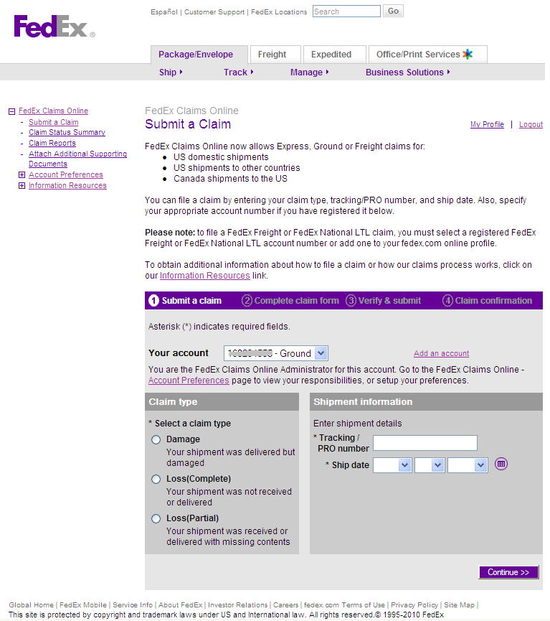

## Filing a Claim by Phone

If the customer contacts Customer Service to file a claim, a Customer Service Representative will fax a claim form and Frequently Asked Questions (FAQs) to the customer.

The customer will need to provide information to the Customer Service Representative:

* Complete claim form
* FedEx air waybill or tracking number
* Date of shipment
* Complete shipper and recipient information
* Number of pieces
* Shipment weight
* Contact name and phone number with extension

## Navigational Links - Submit a Claim Home Page

The left side of the Submit a Claim homepage as shown below provides customers quick access to all options within FedEx Claims Online. The navigation bar remains in place when submitting a claim.

**Note:** If you select a Freight Account number, the only links you see on the left panel are “Claims Status Summary” and “Claims Report.”

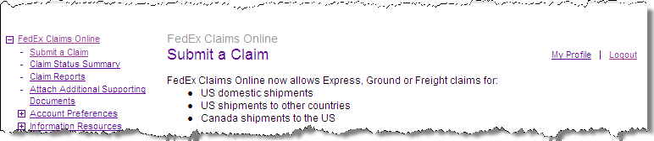

### Submit a Claim Link

This link directs the customer to Step 1 – Submit a claim screen.

### Claim Status Summary link

This link displays a dynamic table where users can select a specific account number and/or search for claims by a selecting a filter from a drop-down list. This Claim Status Summary provides a status summary for all a customer’s claims.   
**NOTE:** Refer to the section Claim Status Summary for more information.

### Claim Reports link

The Claim Reports link offers customers the ability to download to Excel or CSV file formats the same information reporting in the Claim Status Summary.

**NOTE:** Refer to the section Claim Reports for additional information.

### Additional Supporting Documents Link

This link takes the customer to the Attach Additional Supporting Documents page. Please refer to that section for additional instructions.

### Account Preferences link

This link takes the user to the Claims Online Account Preferences.   
**NOTE:** Refer to the Account Preferences section for additional information.

### Information Resources link

Provides additional access links to the following:

* Claims Online Demo – view a demo on Claims Online
* Claims Online Features – find out what Claims Online can do and learn about its features
* Claims Online Overview – find out how our claims process works
* Claim Instructions – claims filing instructions for both Express and Ground Claims
* FAQ – frequently asked questions on claims related issues
* Proper Packaging Guideline – ensure that your packages arrive on time and in good condition with proper packaging, taping and labeling

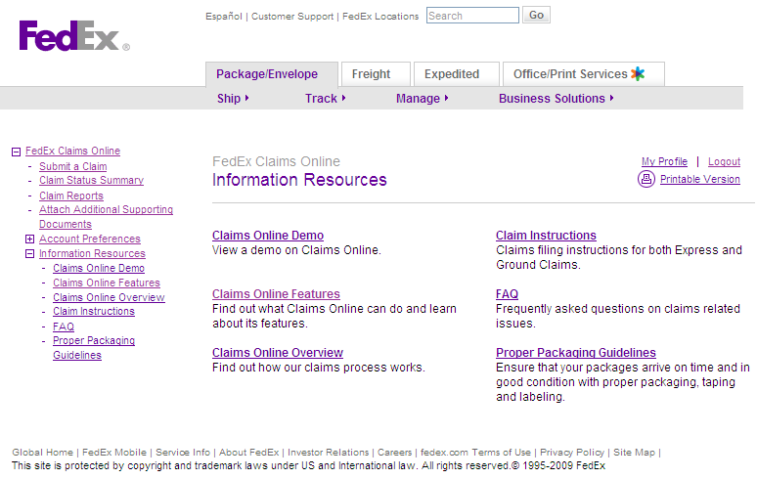

### My Profile link

The My Profile link directs the user to their FedEx profile, which displays a list of the registered account numbers and the applications they are authorized to use with those accounts.

### Logout link

The Logout link logs the user out of the Claims Online application, returning to the FedEx.com home page.

# Submitting a Claim

This screen allows claims for FedEx Express, Ground, or Freight claims on:

* U.S. Domestic shipments (including FedEx Ground Call Tag and FedEx Express Tag shipments)
* U.S. shipments outbound to other countries
* Canada shipments inbound to the U.S.

## Step 1 – Submit a claim

If the first account number in the “Your account” drop-down listing is a FedEx Express/Ground account, or if the customer selects a FedEx Express/Ground account number from the drop-down menu, they are automatically routed to the Claims Online page to enter their claim information, as shown below.

To file a claim the customer must select one of the three Claim Types followed by the Shipment Information. When all required fields have been selected and entered, click **Continue**.

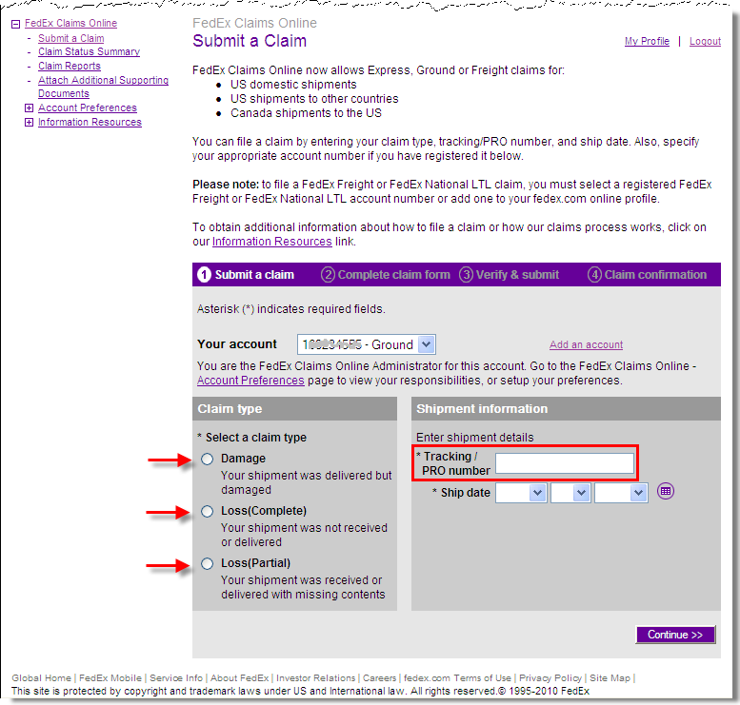

**Reminder:** For Express Tag claims, the “FedEx Express Control Number” or for Ground Call Tag claims, the “FedEx Ground Damaged Call Tag Confirmation Number” is entered in the “Tracking/ PRO number” field. Refer to **KB # 3301** – Obtaining a Blank Claim Form for Lost or Damaged Shipments for more information.

If the customer selects a FedEx Freight account number from the drop-down menu, they are routed to the Freight Claims Online website, as shown below.

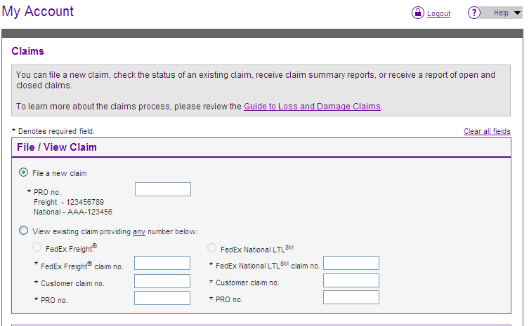

### Possible Claims Alert Messages

A message appears if the customer filing the claim is not the shipper of the package with notification of the following limitations.

#### Claim Filer – Not Shipper Error

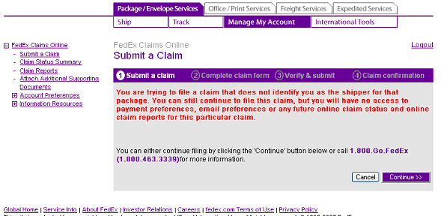

The following message appears if Damage is the Claim Type selected and the Ship Date for the Tracking number entered is older than **21 days**.

#### Damage Claim – 21 Days Limit Exceeded Error

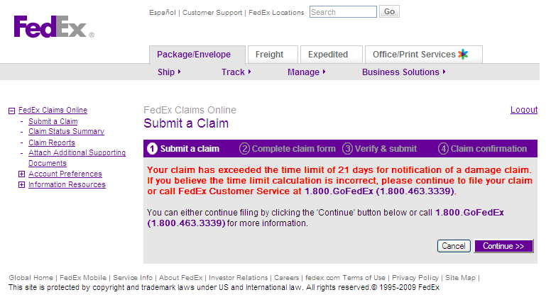

## Step 2 – Complete claim form

Information on the second Claims Online screen will appear differently depending on the type of claim the customer is filing / submitting.

Sections A and B automatically pre-populate with the Sender and Recipient information from the FedEx shipment database. The customer selects the claimant type and then scrolls down to complete the rest of the claim form.

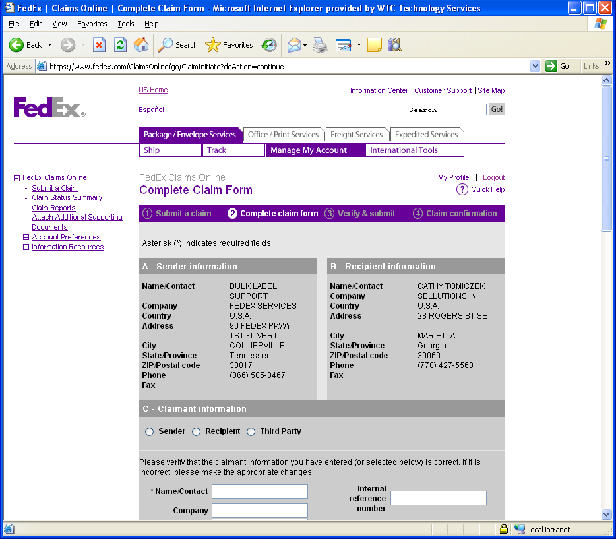

**Scroll down**

Section C information automatically fills with the appropriate Claimant’s information.

Customers can verify and edit claimant information and can check the Proactive emails box to receive proactive emails for claim statuses, with up to four recipient email addresses being allowed.  
**Reminder:** Claimant information is based on the claimant type chosen (shipper, recipient, or third party).

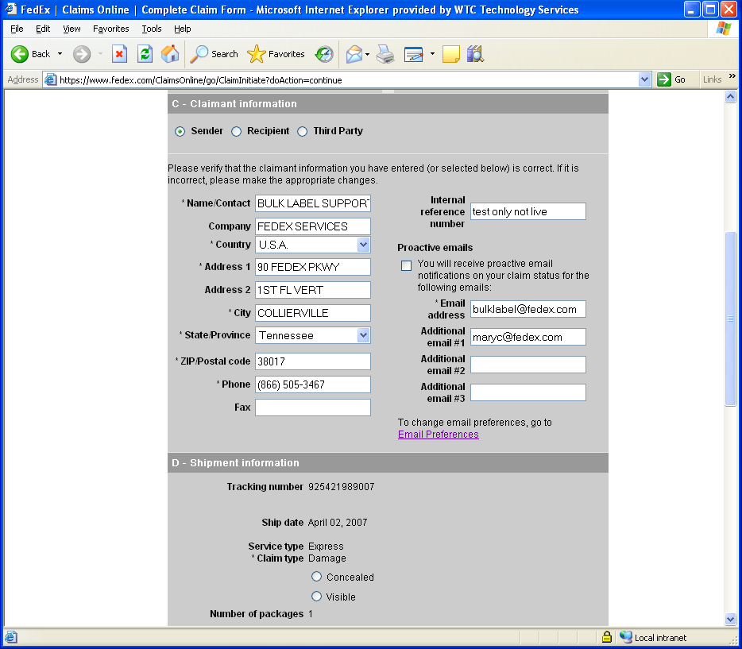

The customer continues scrolling on down the page, advancing to Section D. Shipment information.

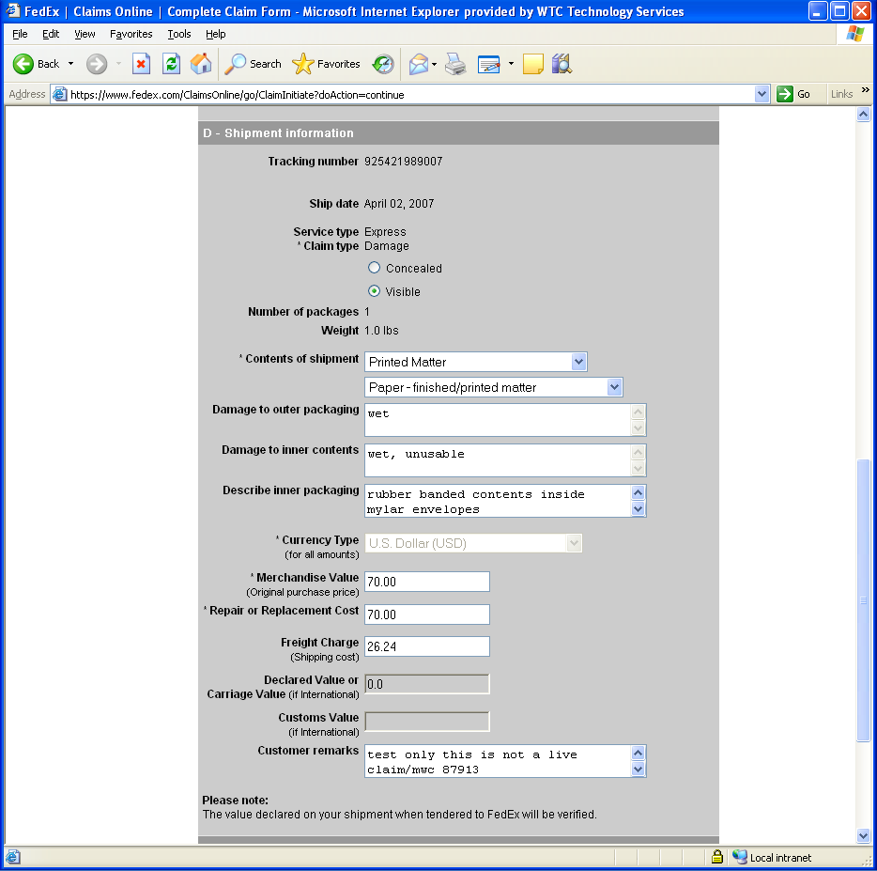

## Step 3 – Verify & submit

The last step is to have the customer review the information for accuracy, as well as choose the type of refund preferred.

Customers can choose to receive a check or have funds sent to their banking institution via Electronic Funds Transfer (EFT).   
**NOTE:** Customers must already have banking account number information previously setup with FedEx before that option can be selected.

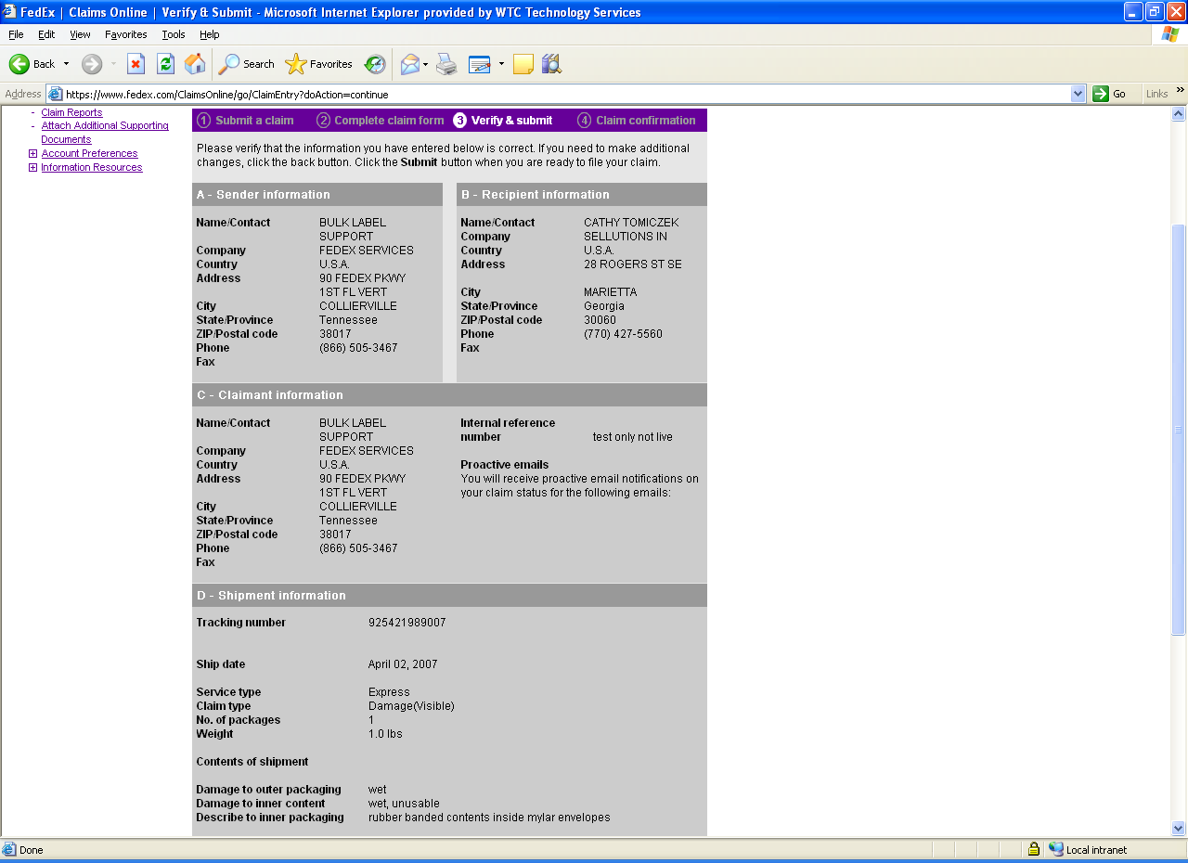

## Step 4 – Claim confirmation

Customers should then print the confirmation page and follow the instructions provided, attaching supporting documentation as needed and/or required for the claim.   
**NOTE:** Documentation may be electronically attached to the Claims Online form or faxed.

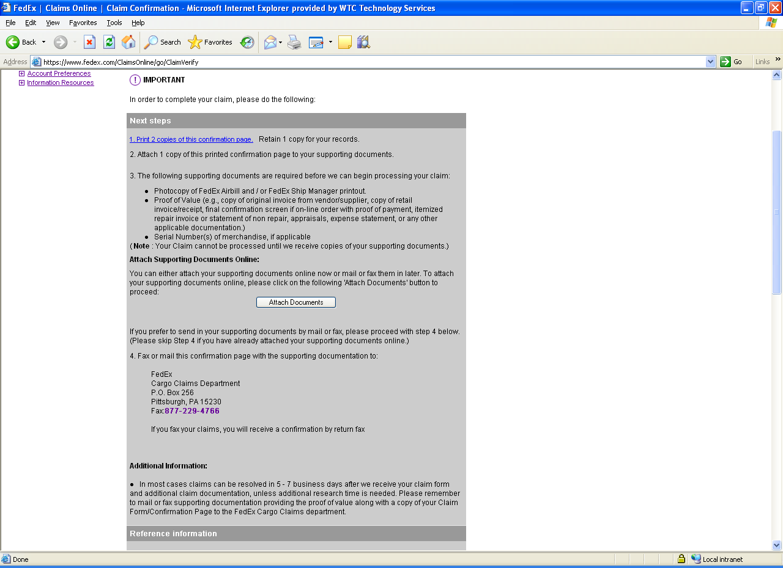

# Attach Additional Supporting Documents

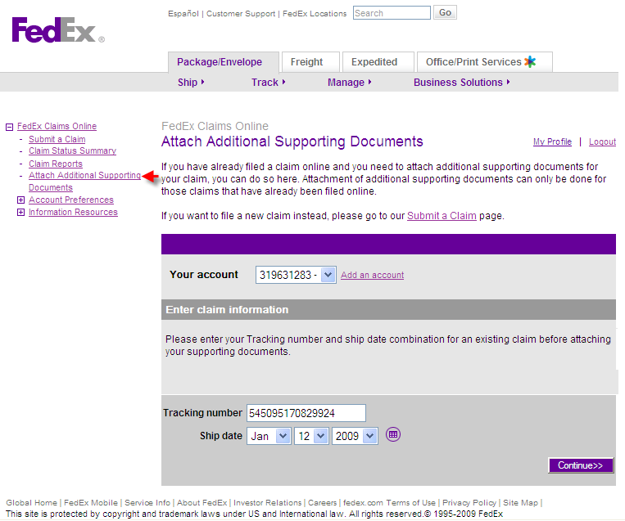

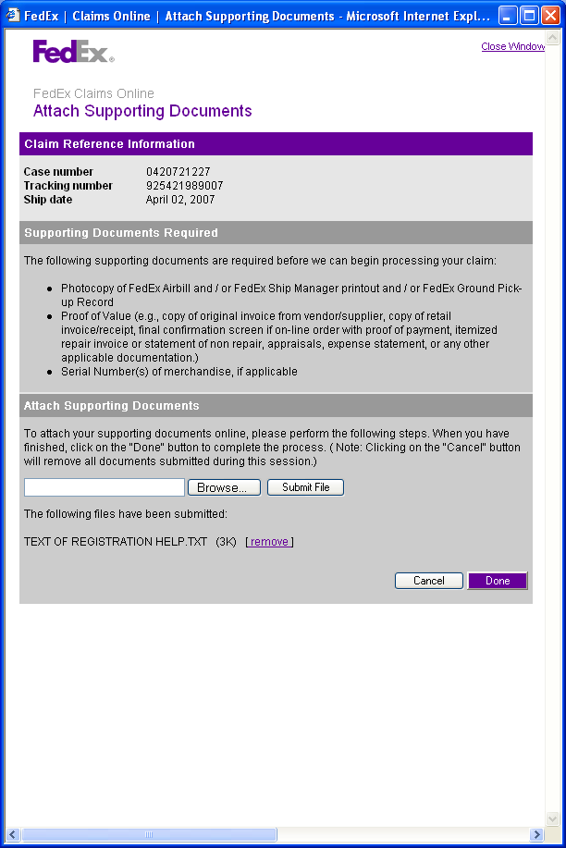

KB articles for reference

KB 7599 - Completing Registration for Claims Online (View 1 and View 2)

KB 7600 - Claims Online: Submitting a Claim Online

KB 7605 - Claims Online: Attaching Supporting Documents to a Claim

KB 9881 - Claims Error: We Are Unable to Process Your Request

KB 7604 - Claims Online: Examples of Proactive E-mails Sent to Customers

* From the Attach Supporting screen, the customer clicks the Browse button to locate the necessary document(s) to attach.
* When complete, the customer clicks Done to return to the Claim Confirmation screen

# Account Preferences

Account Preferences can be accessed via the Left Navigation link or from the Submit a Claim homepage, and upon clicking the link, the Account Preferences screen displays as shown below.

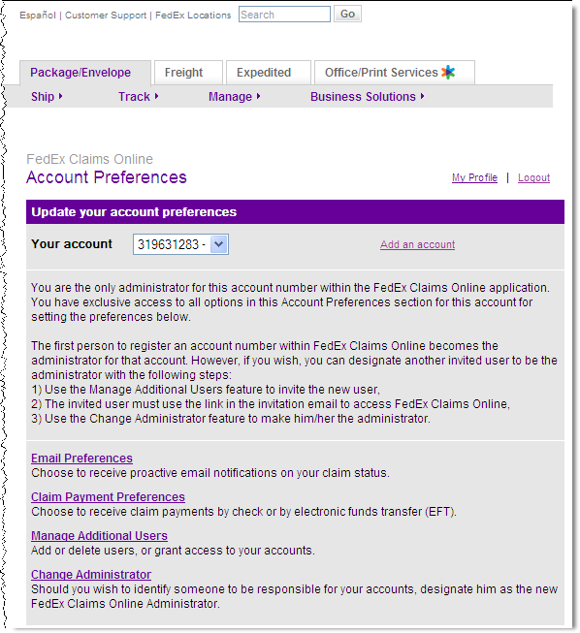

## Email Preferences screen

Users can setup up to **four** email addresses for receiving proactive notifications on claim statuses.

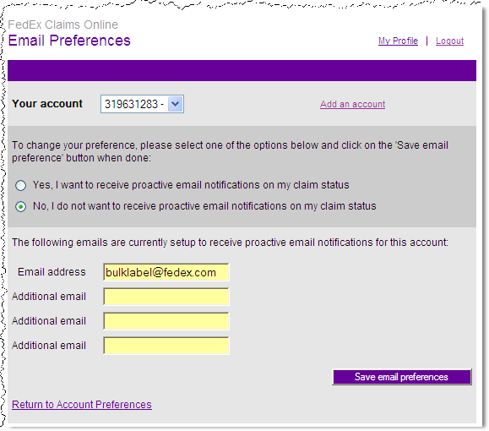

## Claim Payment Preferences link

Allows the customer the option on how they can receive compensation for their claim. The options are check or EFT.  
**NOTE:** For payment by EFT, customers must already have a bank account registered with FedEx.

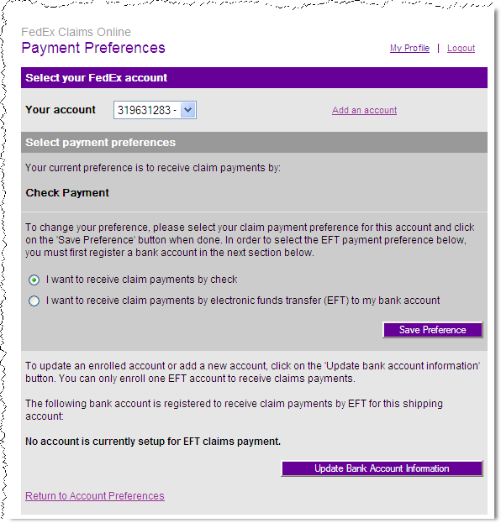

## Manage Additional Users link

On this screen, users can add additional accounts, delete users, and invite new users.

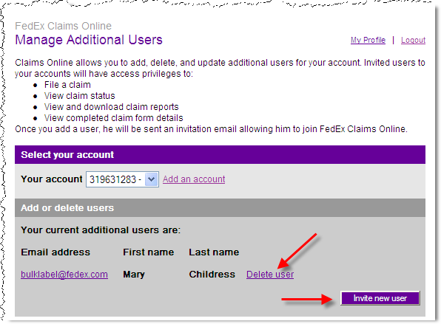

### Invite New Users button

Users must enter all three fields before select the Invite new user button.  
**NOTE:** The email address entered must belong to the same email address domain of the Administrator (i.e. @fedex.com)

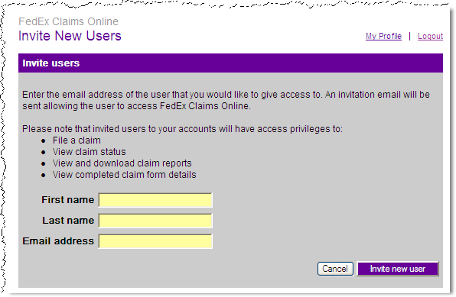

**Reminder:** All secondary users to Claims online have the same privileges as the Administrator.

## Change Administrator link

The Change Administrator link allows the existing Administrator the option to transfer administrative rights to another invited user.

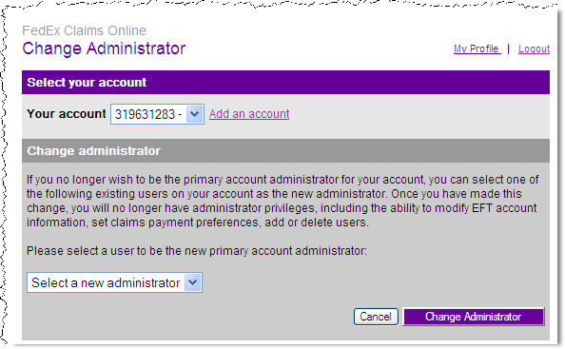

# Claim Status Summary

Customers may view the status of Pending claims by clicking on the Claim Status link at the left side from the FedEx Claims Online – Submit a Claim homepage. Users may select several Search claims by criteria from the drop-down list, and after selecting a criteria and selecting a From and To date range, click the Search button.

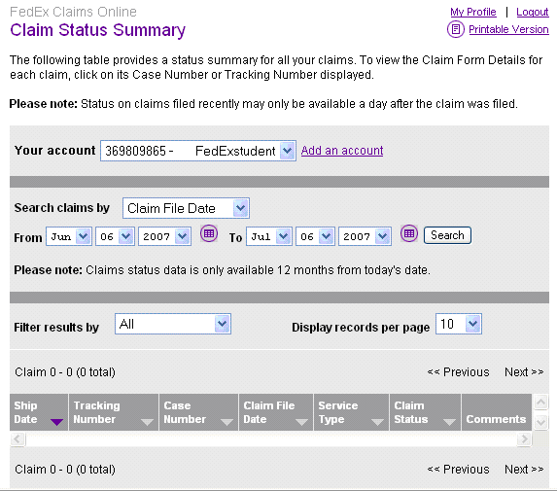

# Claim Reports

Claim reports can be displayed on the screen, printed, or exported to a Microsoft Excel file or to a Comma delimited file (CSV) by clicking on the Claim Reports link located on the left side of the FedEx Claims Online – Submit a Claim homepage as shown below.

The Claim Reports table provides claim report details on all a customer’s claims.

To view the Claim Form Details for each claim, click on its Case Number or Tracking Number displayed.   
**Reminder: The** status on claims filed recently may only be available a day after the claim was filed.

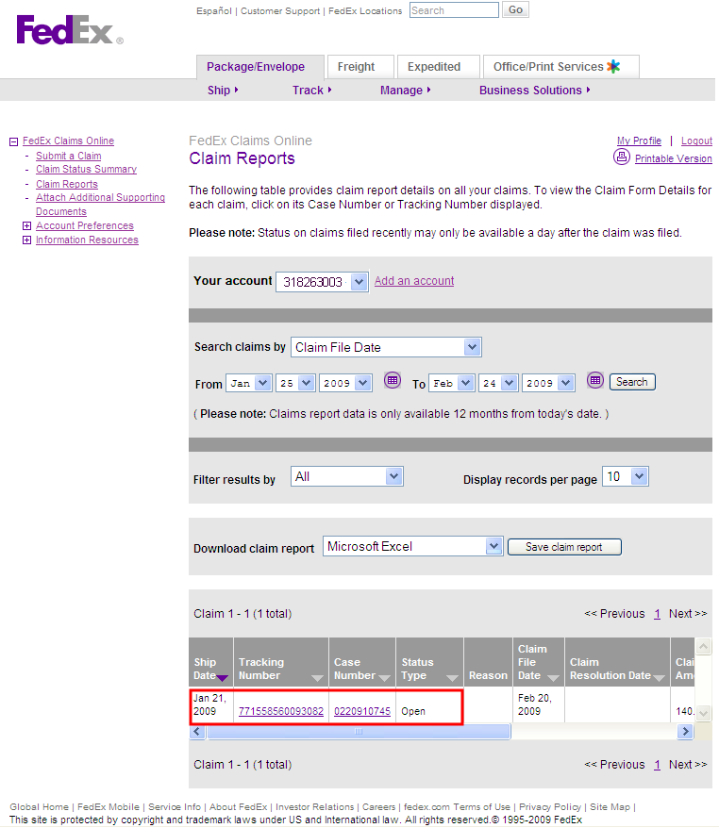

Screen entry fields and drop-down options for this page are:

* Your account drop-down – defaults to the primary account entered during registration.
* Search claims by drop-down
* Ship Date
* Claims Resolution Date
* Customer Reference Number
  + Claim File Date (default)
  + Case Number
  + Tracking Number
* From and To Calendar Dates
* Filter results by: Open or Closed
* Display records per page: 10, 20, 30, 50, 100 200 500, or All
* Download claim report: Microsoft Excel or Comma delimited file (CSV)

Sample Claim Report – Exported to Microsoft Excel

